Acceptance Testing
UAT Execution & Report Submission

Date | 17 February 2026
Team ID | LVIP2026TMIDSB7385
Project Name | AI Travel Itinerary Generator using Streamlit & Gemini API
Maximum Marks

1. Purpose of Document
The purpose of this document is to summarize the User Acceptance Testing (UAT) results for the AI Travel Itinerary Generator application. It explains test coverage, execution results, and observed issues at the time of release. The goal is to confirm that the system meets user requirements for generating personalized travel itineraries based on destination, duration, and interests.
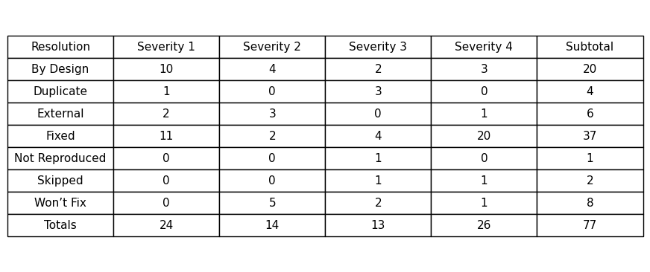
2. Defect Analysis Table

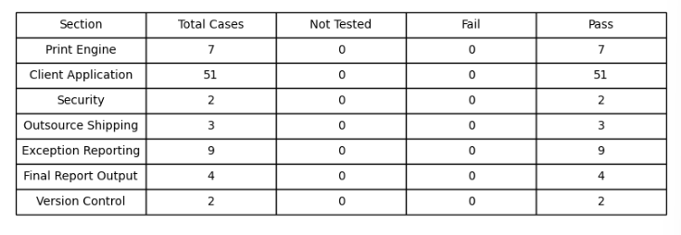
Test Case Analysis Table

